Lecture 4.

Physiology of microorganisms. Metabolism, nutrition, respiration and multiplication. Principles of cultivation of microorganisms

The purpose of the lecture: To acquaint students with the physiology of microorganisms, metabolism, nutrition, respiratory and reproductive characteristics, as well as the principles of cultivation.
Lecture plan:
1. Physiology, metabolism, nutrition, respiration and reproduction of microorganisms.
- The concept of the physiology of microorganisms.
- Chemical composition of microorganisms.
- Metabolism of microorganisms (anabolism and catabolism).
- Types of nutrition of bacteria. Carbohydrates, energy, electrons, nitrogen sources, growth factors.
- Differentiation of microorganisms by types of food (autotrophs, heterotrophs, phototrophs, chemotrophs, lithotrophs, organotrophs, aminoautotrophs, aminoheterotrophs, prototrophs, auxotrophs, saprophytes and parasites). Mechanism of bacterial nutrition: passive diffusion, facilitated diffusion, active transport, translocation.
- Energy metabolism. Respiration and respiratory types of bacteria (obligate aerobes, microaerophiles, facultative anaerobes, capnophiles, obligate anaerobes).
- Products of vital activity of microorganisms, enzymes, pigments.
- Biological significance of bacterial enzymes. Constructive and inductive enzymes. Endo and exoenzymes. Metabolic and aggression enzymes. The role of enzymes in metabolism and pathogenesis. The role of the study of enzymes in the identification of microorganisms.
- Reproduction of bacteria. Reproductive phases.
- Reproduction of spirochetes, mycoplasmas and actinomycetes.
- Basic principles of rickettsia, chlamydia and virus cultivation. Methods of indication and identification of viruses.
- Principles of cultivation of microorganisms.
- Nutrient media, their types: basic (simple), special, elective, differential-diagnostic, conservation (transportation). Basic requirements for nutrient media.

The bacterial cell membrane, also called the cytoplasmic membrane, is visible in electron micrographs of thin sections. It is a typical “unit membrane” composed of phospholipids and upward of 200 different kinds of proteins. Proteins account for approximately 70% of the mass of the membrane, which is a considerably higher proportion than that of mammalian cell membranes. The membranes of prokaryotes are distinguished from those of eukaryotic cells by the absence of sterols, the only exception being mycoplasmas that incorporate sterols, such as cholesterol, into their membranes when growing in sterol-containing media. The cell membranes of the Archaea differ from those of the Bacteria. Some Archaeal cell membranes contain unique lipids, isoprenoids, rather than fatty acids, linked to glycerol by ether rather than an ester linkage. Some of these lipids have no phosphate groups, and therefore, they are not phospholipids. In other species, the cell membrane is made up of a lipid monolayer consisting of long lipids (about twice as long as a phospholipid) with glycerol ethers at both ends (diglycerol tetraethers). The molecules orient themselves with the polar glycerol groups on the surfaces and the nonpolar hydrocarbon chain in the interior. These unusual lipids contribute to the ability of many Archaea to grow under environmental conditions such as high salt, low pH, or very high temperature.
B. Function
The major functions of the cytoplasmic membrane are (1) selective permeability and transport of solutes; (2) electron transport and oxidative phosphorylation in aerobic species; (3) excretion of hydrolytic exoenzymes; (4) bearing the enzymes and carrier molecules that function in the biosynthesis of DNA, cell wall polymers, and membrane lipids; and (5) bearing the receptors and other proteins of the chemotactic and other sensory transduction systems. At least 50% of the cytoplasmic membrane must be in the semifluid state for cell growth to occur. At low temperatures, this is achieved by greatly increased synthesis and incorporation of unsaturated fatty acids into the phospholipids of the cell membrane.
1. Permeability and transport—The cytoplasmic membrane forms a hydrophobic barrier impermeable to most hydrophilic molecules. However, several mechanisms (transport systems) exist that enable the cell to transport nutrients into and waste products out of the cell. These transport systems work against a concentration gradient to increase the concentration of nutrients inside the cell, a function that requires energy in some form. There are three general transport mechanisms involved in membrane transport: passive transport, active transport, and group translocation.
a. Passive transport—This mechanism relies on diffusion, uses no energy, and operates only when the solute is at higher concentration outside than inside the cell. Simple diffusion accounts for the entry of very few nutrients, including dissolved oxygen, carbon dioxide, and water itself. Simple diffusion provides neither speed nor selectivity. Facilitated diffusion also uses no energy so the solute never achieves an internal concentration greater than what exists outside the cell. However, facilitated diffusion is selective. Channel proteins form selective channels that facilitate the passage of specific molecules. Facilitated diffusion is common in eukaryotic microorganisms (eg, yeast) but is rare in prokaryotes. Glycerol is one of the few compounds that enters prokaryotic cells by facilitated diffusion.
b. Active transport—Many nutrients are concentrated more than a thousand-fold as a result of active transport. There are two types of active transport mechanisms depending on the source of energy used: ion-coupled transport and ATP-binding cassette (ABC) transport.
1) Ion-coupled transport—These systems move a molecule across the cell membrane at the expense of a previously established ion gradient such as protonmotive or sodium motive force. There are three basic types: uniport, symport, and antiport. Ion-coupled transport is particularly common in aerobic organisms, which have an easier time generating an ion-motive force than do anaerobes. Uniporters catalyze the transport of a substrate independent of any coupled ion. Symporters catalyze the simultaneous transport of two substrates in the same direction by a single carrier; for example, an H+ gradient can permit symport of an oppositely charged ion (eg, glycine) or a neutral molecule (eg, galactose).
Antiporters catalyze the simultaneous transport of two likecharged compounds in opposite directions by a common carrier (eg, H+:Na+). Approximately 40% of the substrates transported by E coli use this mechanism.
2) ABC transport—This mechanism uses ATP directly to transport solutes into the cell. In gram-negative bacteria, the transport of many nutrients is facilitated by specific binding proteins located in the periplasmic space; in grampositive cells, the binding proteins are attached to the outer surface of the cell membrane. These proteins function by transferring the bound substrate to a membrane-bound protein complex. Hydrolysis of ATP is then triggered, and the energy is used to open the membrane pore and allow the unidirectional movement of the substrate into the cell. Approximately 40% of the substrates transported by E coli use this mechanism.
c. Group translocation—In addition to true transport, in which a solute is moved across the membrane without change in structure, bacteria use a process called group translocation (vectorial metabolism) to effect the net uptake of certain sugars (eg, glucose and mannose), the substrate becoming phosphorylated during the transport process. In a strict sense, group translocation is not active transport because no concentration gradient is involved.
This process allows bacteria to use their energy resources efficiently by coupling transport with metabolism. In this process, a membrane carrier protein is first phosphorylated in the cytoplasm at the expense of phosphoenolpyruvate; the phosphorylated carrier protein then binds the free sugar at the exterior membrane face and transports it into the cytoplasm, releasing it as sugar phosphate. Such systems of sugar transport are called phosphotransferase systems. Phosphotransferase systems are also involved in movement toward these carbon sources (chemotaxis) and in the regulation of several other metabolic pathways (catabolite repression).
d. Special transport processes—Iron (Fe) is an essential nutrient
for the growth of almost all bacteria. Under anaerobic conditions, Fe is generally in the +2 oxidation state and soluble. However, under aerobic conditions, Fe is generally in the +3 oxidation state and insoluble. The internal compartments of animals contain virtually no free Fe; it is sequestered in complexes with such proteins as transferrin and lactoferrin. Some bacteria solve this problem by secreting siderophores—compounds that chelate Fe and promote its transport as a soluble complex. One major group of siderophores consists of derivatives of hydroxamic acid (−CONH2OH), which chelate Fe3+ very strongly. The iron– hydroxamate complex is actively transported into the cell by the cooperative action of a group of proteins that span the outer membrane, periplasm, and inner membrane. The iron is released, and the hydroxamate can exit the cell and be used again for iron transport. Some pathogenic bacteria use a fundamentally different mechanism involving specific receptors that bind host transferrin and lactoferrin (as well as other iron-containing host proteins). The Fe is removed and transported into the cell by an energy-dependent process.
2. Electron transport and oxidative phosphorylation—The cytochromes and other enzymes and components of the respiratory chain, including certain dehydrogenases, are located in the cell membrane. The bacterial cell membrane is thus a functional analog of the mitochondrial membrane—a relationship which has been taken by many biologists to support the theory that mitochondria have evolved from symbiotic bacteria. The mechanism by which ATP generation is coupled to electron transport is discussed.
3. Excretion of hydrolytic exoenzymes and pathogenicity proteins—All organisms that rely on macromolecular organic polymers as a source of nutrients (eg, proteins, polysaccharides, lipids) excrete hydrolytic enzymes that degrade the polymers to subunits small enough to penetrate the cell membrane. Higher animals secrete such enzymes into the lumen of the digestive tract; bacteria (both gram positive and gram negative) secrete them directly into the external medium or into the periplasmic space between the peptidoglycan layer and the outer membrane of the cell wall in the case of gram-negative bacteria (see The Cell Wall, later). In gram-positive bacteria, proteins are secreted directly, but proteins secreted by gram-negative bacteria must traverse the outer membrane as well. Six pathways of protein secretion have been described in bacteria: the type I, type II, type III, type IV, type V, and type VI secretion systems. A schematic overview of the type I to V systems is presented in Figure 2-13. The type I and IV secretion systems have been described in both gram-negative and gram-positive bacteria, but the type II, III, V, and VI secretion systems have been found only in gram-negative bacteria. Proteins secreted by the type I and III pathways traverse the inner membrane (IM) and outer membrane (OM) in one step, but proteins secreted by the type II and V pathways cross the IM and OM in separate steps. Proteins secreted by the type II and V pathways are synthesized on cytoplasmic ribosomes as preproteins containing an extra leader or signal sequence of 15–40 amino acids—most commonly about 30 amino acids—at the amino terminal and require the sec system for transport across the IM. In E coli, the sec pathway comprises a number of IM proteins (SecD to SecF, SecY), a cell membrane–associated ATPase (SecA) that provides energy for export, a chaperone (SecB) that binds to the preprotein, and the periplasmic signal peptidase. After translocation, the leader sequence is cleaved off by the membrane-bound signal peptidase, and the mature protein is released into the periplasmic space. In contrast, proteins secreted by the type I and III systems do not have a leader sequence and are exported intact.
In gram-negative and gram-positive bacteria, another plasma membrane translocation system, called the tat pathway, can move proteins across the plasma membrane. In gramnegative bacteria, these proteins are then delivered to the type II system. The tat pathway is distinct from the sec system in that it translocates already folded proteins. Although proteins secreted by the type II and V systems are similar in the mechanism by which they cross the IM, differences exist in how they traverse the OM. Proteins secreted by the type II system are transported across the OM by a multiprotein complex. This is the primary pathway for the secretion of extracellular degradative enzymes by gram negative bacteria. Elastase, phospholipase C, and exotoxin A are secreted by this system in Pseudomonas aeruginosa. However, proteins secreted by the type V system autotransport across the outer membrane by virtue of a carboxyl terminal sequence, which is enzymatically removed upon release of the protein from the OM. Some extracellular proteins—eg, the IgA protease of Neisseria gonorrhoeae and the vacuolating cytotoxin of Helicobacter pylori—are secreted by this system.

The type I and III secretion pathways are sec independent and thus do not involve amino terminal processing of the secreted proteins. Protein secretion by these pathways occurs in a continuous process without the presence of a cytoplasmic intermediate. Type I secretion is exemplified by the α-hemolysin of E coli and the adenylyl cyclase of Bordetella pertussis.
The protein secretion systems of gram-negative bacteria. Five secretion systems of gram-negative bacteria are shown. The Sec-dependent and Tat pathways deliver proteins from the cytoplasm to the periplasmic space. The type II, type V, and sometimes type IV systems complete the secretion process begun by the Sec-dependent pathway. The Tat system appears to deliver proteins only to the type II pathway. The type I and III systems bypass the Sec-dependent and Tat pathways, moving proteins directly from the cytoplasm, through the outer membrane, to the extracellular space. The type IV system can work either with the Sec-dependent pathway or can work alone to transport proteins to the extracellular space. Proteins translocated by the Sec-dependent pathway and the type III pathway are delivered to those systems by chaperone proteins. ADP, adenosine diphosphate; ATP, adenosine triphosphate; EFGY; PuIS; SecD; TolC; Yop.
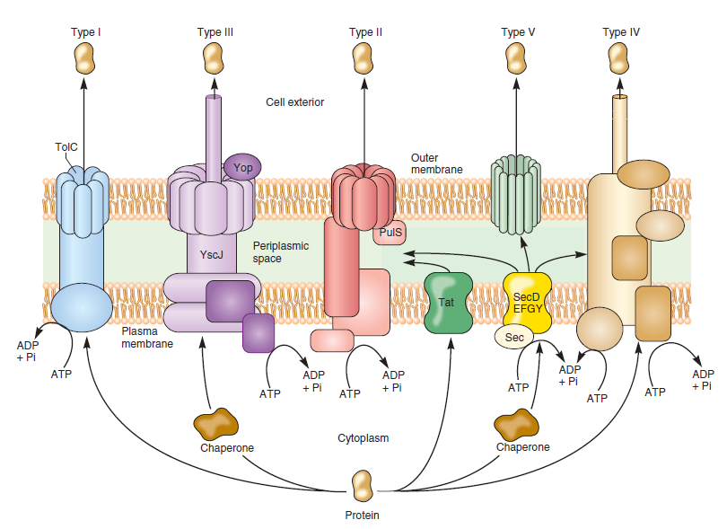

Type I secretion requires three secretory proteins: an IM ATP binding cassette (ABC transporter), which provides energy for protein secretion; an OM protein; and a membrane fusion protein, which is anchored in the inner membrane and spans the periplasmic space. Instead of a signal peptide, the information is located within the carboxyl terminal 60 amino acids of the secreted protein. The type III secretion pathway is a contact-dependent system. It is activated by contact with a host cell, and then injects a toxin protein into the host cell directly. The type III secretion apparatus is composed of approximately 20 proteins, most of which are located in the IM. Most of these IM components are homologous to the flagellar biosynthesis apparatus of both gram-negative and gram-positive bacteria. As in type I secretion, the proteins secreted via the type III pathway are not subject to amino terminal processing during secretion.
Type IV pathways secrete either polypeptide toxins (directed against eukaryotic cells) or protein–DNA complexes either between two bacterial cells or between a bacterial and a eukaryotic cell. Type IV secretion is exemplified by the protein–DNA complex delivered by Agrobacterium tumefaciens into a plant cell. Additionally, B pertussis and H pylori possess type IV secretion systems that mediate secretion of pertussis toxin and interleukin-8–inducing factor, respectively.
The sec-independent type VI secretion was recently described in P aeruginosa, where it contributes to pathogenicity in patients with cystic fibrosis. This secretion system is composed of 15–20 proteins whose biochemical functions are not well understood. However, recent studies suggest that some of these proteins share homology with bacteriophage tail proteins. The characteristics of the protein secretion systems of bacteria are summarized in Table 9-5.
4. Biosynthetic functions—The cell membrane is the site of the carrier lipids on which the subunits of the cell wall are assembled (see the discussion of synthesis of cell wall substances in Chapter 6) as well as of the enzymes of cell wall biosynthesis. The enzymes of phospholipid synthesis are also localized in the cell membrane.
5. Chemotactic systems—Attractants and repellents bind to specific receptors in the bacterial membrane (see Flagella, later). There are at least 20 different chemoreceptors in the membrane of E coli, some of which also function as a first step in the transport process.
The three major mechanisms for generating metabolic energy are fermentation, respiration, and photosynthesis. At least one of these mechanisms must be used if an organism is to grow.

Fermentation
The formation of ATP in fermentation is not coupled to the transfer of electrons. Fermentation is characterized by substrate phosphorylation, an enzymatic process in which a pyrophosphate bond is donated directly to adenosine diphosphate (ADP) by a phosphorylated metabolic intermediate. The phosphorylated intermediates are formed by metabolic rearrangement of a fermentable substrate such as glucose, lactose, or arginine. Because fermentations are not accompanied by a change in the overall oxidation-reduction state of the fermentable substrate, the elemental composition of the products of fermentation must be identical to those of the substrates. For example, fermentation of a molecule of glucose (C6H12O6) by the Embden-Meyerhof pathway yields a net gain of two pyrophosphate bonds in ATP and produces two molecules of lactic acid (C3H6O3).

Respiration
Respiration is analogous to the coupling of an energy-dependent process to the discharge of a battery. Chemical reduction of an oxidant (electron acceptor) through a specific series of electron carriers in the membrane establishes the proton motive force across the bacterial membrane. The reductant (electron donor) may be organic or inorganic (eg, lactic acid serves as a reductant for some organisms, and hydrogen gas is a reductant for other organisms). Gaseous oxygen (O2) often is used as an oxidant, but alternative oxidants that are used by some organisms include carbon dioxide (CO2), sulfate (SO4 2-), and nitrate (NO3-).

Photosynthesis
Photosynthesis is similar to respiration in that the reduction of an oxidant via a specific series of electron carriers establishes the proton motive force. The difference in the two processes is
that in photosynthesis, the red ctant and oxidant are created photochemically by light energy absorbed by pigments in the membrane; thus, photosynthesis can continue only as long as there is a source of light energy. Plants and some bacteria are able to invest a substantial amount of light energy in making water a reductant for carbon dioxide. Oxygen is evolved in this process, and organic matter is produced. Respiration, the energetically favorable oxidation of organic matter by an electron acceptor such as oxygen, can provide photosynthetic organisms with energy in the absence of light.

NUTRITION -Nutrients in growth media must contain all the elements necessary for the biologic synthesis of new organisms. In the following discussion, nutrients are classified according to the elements they supply.

Carbon Source
As already mentioned, plants and some bacteria are able to use photosynthetic energy to reduce carbon dioxide at the expense of water. These organisms are referred to as autotrophs, creatures that do not require organic nutrients for growth. Other autotrophic microorganisms are the chemolithotrophs, organisms that use an inorganic substrate such as hydrogen or thiosulfate as a reductant and carbon dioxide as a carbon source.
Heterotrophs require organic carbon for growth, and the organic carbon must be in a form that can be assimilated. Naphthalene, for example, can provide all of the carbon and energy required for respiratory heterotrophic growth, but very few organisms possess the metabolic pathway necessary for naphthalene assimilation. Glucose, on the other hand, can support the fermentative or respiratory growth of many organisms. It is important that growth substrates be supplied at levels appropriate for the microbial strain that is being grown: Levels that will support the growth of one organism may inhibit the growth of another organism. Carbon dioxide is required for a number of biosynthetic reactions. Many respiratory organisms produce more than enough carbon dioxide to meet this requirement, but others require a source of carbon dioxide in their growth medium.

Nitrogen Source
Nitrogen is a major component of proteins, nucleic acids, and other compounds, accounting for approximately 5% of the dry weight of a typical bacterial cell. Inorganic dinitrogen (N2) is very prevalent, comprising 80% of the earth’s atmosphere. It is also a very stable compound, primarily because of the high activation energy required to break the nitrogen–nitrogen triple bond. However, nitrogen may be supplied in a number of different forms, and microorganisms vary in their abilities to assimilate nitrogen (Table 5-1). The end product of all pathways for nitrogen assimilation is the most reduced form of the element, ammonia (NH3). When NH3 is available, it diffuses into most bacteria through transmembrane channels as dissolved gaseous NH3 rather than ionic ammonium ion (NH4 +).
The ability to assimilate N2 reductively via NH3, which is called nitrogen fixation, is a property unique to prokaryotes, and relatively few bacteria are capable of breaking the nitrogen–nitrogen triple bond. This process (see Chapter 6) requires a large amount of metabolic energy and is readily inactivated by oxygen. The capacity for nitrogen fixation is found in widely divergent bacteria that have evolved quite different biochemical strategies to protect their nitrogen fixing enzymes from oxygen. Most microorganisms can use NH3 as a sole nitrogen source, and many organisms possess the ability to produce NH3 from amines (R—NH2) or from amino acids (RCHNH2COOH), generally intracellularly. Production of NH3 from the deamination of amino acids is called ammonification. Ammonia is introduced into organic matter by biochemical pathways involving glutamate and glutamine. Many microorganisms possess the ability to assimilate nitrate (NO3-) and nitrite (NO2-) reductively by conversion of these ions into NH3. These processes are termed assimilatory nitrate reduction and assimilatory nitrite reduction, respectively. These pathways for assimilation differ from pathways used for dissimilation of nitrate and nitrite. The dissimilatory pathways are used by organisms that use these ions as terminal electron acceptors in respiration. Some autotrophic bacteria (eg, Nitrosomonas, Nitrobacter spp.) are able to convert NH3 to gaseous N2 under anaerobic conditions; this process is known as denitrification. Our understanding of the nitrogen cycle continues to evolve. In the mid 1990 s, the anammox reaction was discovered. The reaction NH4+ +NO2− _N2 + 2H2O in which ammonia is oxidized by nitrite is a microbial process that occurs in anoxic waters of the ocean and is a major pathway by which nitrogen is returned to the atmosphere.

Sulfur Source
Similar to nitrogen, sulfur is a component of many organic cell substances. It forms part of the structure of several coenzymes and is found in the cysteinyl and methionyl side chains of proteins. Sulfur in its elemental form cannot be used by plants or animals. However, some autotrophic bacteria can oxidize it to sulfate (SO4 2-). Most microorganisms can use sulfate as a sulfur source, reducing the sulfate to the level of hydrogen sulfide (H2S). Some microorganisms can assimilate H2S directly from the growth medium, but this compound can be toxic to many organisms.

Phosphorus Source
Phosphate (PO4 3-) is required as a component of ATP; nucleic acids, and such coenzymes as NAD, NADP, and flavins. In addition, many metabolites, lipids (phospholipids, lipid A), cell wall components (teichoic acid), some capsular polysaccharides, and some proteins are phosphorylated. Phosphate is always assimilated as free inorganic phosphate (Pi).

Mineral Sources
Numerous minerals are required for enzyme function. Magnesium ion (Mg2+) and ferrous ion (Fe2+) are also found in porphyrin derivatives: magnesium in the chlorophyll molecule, and iron as part of the coenzymes of the cytochromes and peroxidases. Mg2+ and K+ are both essential for the function and integrity of ribosomes. Ca2+ is required as a constituent of gram-positive cell walls, although it is dispensable for gram-negative bacteria. Many marine organisms require Na+ for growth. In formulating a medium for the cultivation of most microorganisms, it is necessary to provide sources of potassium, magnesium, calcium, and iron, usually as their ions (K+, Mg2+, Ca2+, and Fe2+). Many other minerals (eg, Mn2+, Mo2+, Co2+, Cu2+, and Zn2+) are required; these frequently can be provided in tap water or as contaminants of other medium ingredients.
The uptake of iron, which forms insoluble hydroxides at neutral pH, is facilitated in many bacteria and fungi by their production of siderophores—compounds that chelate iron and promote its transport as a soluble complex. These include hydroxamates (-CONH2OH) called sideramines, and derivatives of catechol (eg, 2,3-dihydroxy-benzoylserine). Plasmid determined siderophores play a major role in the invasiveness of some bacterial pathogens. Siderophoreand non siderophore-dependent mechanisms of iron uptake by bacteria are discussed.

Growth Factors
A growth factor is an organic compound that a cell must have to grow but that it is unable to synthesize. Many microorganisms, when provided with the nutrients listed above, are able to synthesize all of the building blocks for macromolecules, which are amino acids; purines, pyrimidines, and pentoses (the metabolic precursors of nucleic acids); additional carbohydrates (precursors of polysaccharides); and fatty acids and isoprenoid compounds. In addition, free living organisms must be able to synthesize the complex vitamins that serve as precursors of coenzymes. Each of these essential compounds is synthesized by a discrete sequence of enzymatic reactions; each enzyme is produced under the control of a specific gene. When an organism undergoes a gene mutation resulting in failure of one of these enzymes to function, the chain is broken, and the end product is no longer produced. The organism must then obtain that compound from the environment: The compound has become a growth factor for the organism. This type of mutation can be readily induced in the laboratory.
Different microbial species vary widely in their growth factor requirements. The compounds involved are found in and are essential to all organisms; the differences in requirements reflect differences in synthetic abilities. Some species require no growth factors, but others—such as some of the lactobacilli—have lost, during evolution, the ability to synthesize as many as 30 40 essential compounds and hence require them in the medium.

Temperature requirements for growth. Prokaryotes are commonly divided into five groups based on their optimum growth temperatures. Note that the optimum temperature, the point at which the growth rate is highest, is near the upper limit of the range.
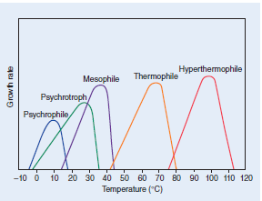

Microorganisms share with plants and animals the heat-shock response, a transient synthesis of a set of “heat-shock proteins,” when exposed to a sudden rise in temperature above the growth optimum. These proteins appear to be unusually heat resistant and to stabilize the heat sensitive proteins of the cell. The relationship of growth rate to temperature for any given microorganism is seen in a typical Arrhenius plot. Arrhenius showed that the logarithm of the velocity of any chemical reaction (log k) is a linear function of the reciprocal of the temperature (1/T); because cell growth is the result of a set of chemical reactions, it might be expected to show this relationship. Case over the normal range of temperatures for a given species; log k decreases linearly with 1/T. Above and below the normal range, however, log k drops rapidly, so that maximum and minimum temperature values are defined.
Beyond their effects on growth rate, extremes of temperature kill microorganisms. Extreme heat is used to sterilize preparations (see Chapter 4); extreme cold also kills microbial cells, although it cannot be used safely for sterilization. Bacteria also exhibit a phenomenon called cold shock, which is the killing of cells by rapid—as opposed to slow—cooling. For example, the rapid cooling of Escherichia coli from 37°C to 5°C can kill 90% of the cells. A number of compounds protect cells from either freezing or cold shock; glycerol and dimethyl sulfoxide are most commonly used.

Aeration
The role of oxygen as hydrogen acceptor is discussed. Many organisms are obligate aerobes, specifically requiring oxygen as hydrogen acceptor; some are facultative anaerobes, able to live aerobically or anaerobically; some are obligate anaerobes requiring a substance other than oxygen as hydrogen acceptor and are sensitive to oxygen inhibition; some are microaerophiles, which require small amounts of oxygen (2–10%) for aerobic respiration (higher concentrations are inhibitory); and others are aerotolerant anaerobes, which are indifferent to oxygen. They can grow in its presence, but they do not use it as a hydrogen acceptor. The natural by-products of aerobic metabolism are the reactive compounds hydrogen peroxide (H2O2) and superoxide (O2 -). In the presence of iron, these two species can generate hydroxyl radicals (•OH), which can damage any biologic macromolecule:
Many aerobes and aerotolerant anaerobes are protected from these products by the presence of superoxide dismutase, an enzyme that catalyzes the reaction 2O2− + 2H+ _O2 +H2O2
and by the presence of catalase, an enzyme that catalyzes the reaction 2H2O2_2H2O+O2
Some fermentative organisms (eg, Lactobacillus plantarum) are aerotolerant but do not contain catalase or superoxide dismutase. Oxygen is not reduced, and therefore H2O2 and O2 - are not produced. All strict anaerobes lack both superoxide dismutase and catalase. Some anaerobic organisms (eg, Peptococcus anaerobius) have considerable tolerance to oxygen as a result of their ability to produce high levels of an enzyme (NADH oxidase) that reduces oxygen to water according to the reaction
Hydrogen peroxide owes much of its toxicity to the damage it causes to DNA. DNA repair deficient mutants are exceptionally sensitive to hydrogen peroxide; the recA gene product,
which functions in both genetic recombination and repair, has been shown to be more important than either catalase or superoxide dismutase in protecting E coli cells against hydrogen peroxide toxicity.
The supply of air to cultures of aerobes is a major technical problem. Vessels are usually shaken mechanically to introduce oxygen into the medium or air is forced through the medium by pressure. The diffusion of oxygen often becomes the limiting factor in growing aerobic bacteria; when a cell concentration of 4–5 × 109/mL is reached, the rate of diffusion of oxygen to the cells sharply limits the rate of further growth.
Obligate anaerobes, on the other hand, present the problem of oxygen exclusion. Many methods are available for this: Reducing agents such as sodium thioglycolate can be added
to liquid cultures, tubes of agar can be sealed with a layer of petrolatum and paraffin, the culture vessel can be placed in a container from which the oxygen is removed by evacuation or by chemical means, or the organism can be handled within an anaerobic glove box.

Ionic Strength and Osmotic Pressure
To a lesser extent, such factors as osmotic pressure and salt concentration may have to be controlled. For most organisms, the properties of ordinary media are satisfactory; however, for marine forms and organisms adapted to growth in strong sugar solutions, for example, these factors must be considered. Organisms requiring high salt concentrations are called halophilic; those requiring high osmotic pressures are called osmophilic. Most bacteria are able to tolerate a wide range of external osmotic pressures and ionic strengths because of their ability to regulate internal osmolality and ion concentration. Osmolality is regulated by the active transport of K+ ions into the cell; internal ionic strength is kept constant by a compensating excretion of the positively charged organic polyamine putrescine. Because putrescine carries several positive charges per molecule, a large drop in ionic strength is effected at only a small cost in osmotic strength.

Oxygen (O2) requirements of prokaryotes.
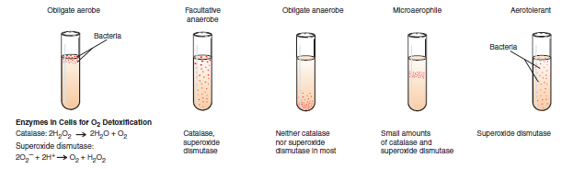

Enrichment culture. Medium and incubation conditions favor the growth of the desired species over other bacteria in the same sample.
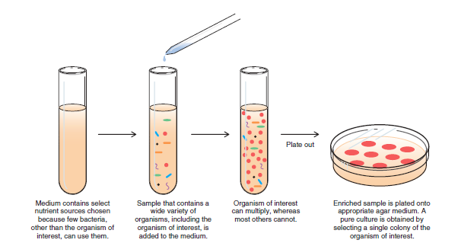

Characteristics of Representative Media Used to Cultivate Bacteria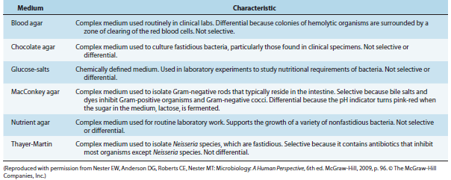

The pour-plate technique. The original sample is diluted several times to thin out the population sufficiently. The most diluted samples are then mixed with warm agar and poured into Petri dishes. Isolated cells grow into colonies and are used to establish pure cultures. The surface colonies are circular; subsurface colonies are lenticular (lens shaped).
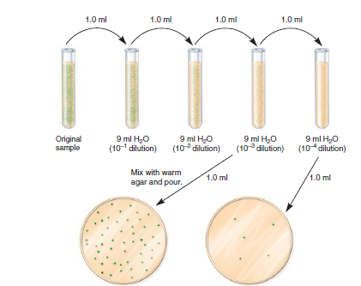

Streak-plate technique. A: A typical streaking pattern. (Reproduced with permission from Willey JM, Sherwood CJ, Woolverton CJ: Prescott, Harley, & Klein’s Microbiology, 7th ed. McCgraw-Hill, 2008. © The McGraw-Hill Companies, Inc.) B: An example of a streak plate.
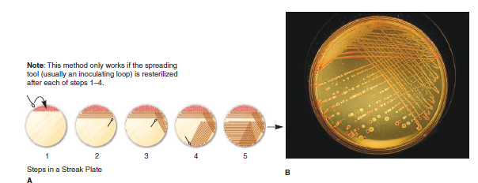

Growth on Media
Suitable criteria for bacterial classification include many of the properties that were described in the preceding chapter. One criterion is growth on different types of bacteriologic media. The general cultivation of most bacteria requires media rich in metabolic nutrients. These media generally include agar, a carbon source, and an acid hydrolysate or enzymatically degraded source of biologic material (eg, casein). Because of the undefined composition of the latter, these types of media are referred to as complex media. Clinical samples from normally nonsterile sites (eg, the throat or the colon) contain multiple species of organisms, including potential pathogens and resident microbial flora. Media can be nonselective or selective; the latter are used to distinguish among the various bacteria in a clinical sample containing many different organisms.

A. Nonselective Media
Blood agar and chocolate agar are examples of complex, nonselective media, which support the growth of many different bacteria. These media are intended to cultivate as many species as possible, thus giving rise to numerous types of bacterial colonies.

B. Selective Media
Because of the diversity of microorganisms that typically reside at some sampling sites (eg, the skin, respiratory tract, intestines, vagina), selective media are used to eliminate (or reduce) the large numbers of irrelevant bacteria in these specimens. The basis for selective media is the incorporation of an inhibitory agent that specifically selects against the growth of irrelevant bacteria. Examples of such agents are:
• Sodium azide—selects for gram-positive bacteria over gram-negative bacteria
• Bile salts (sodium deoxycholate)—select for gram-negative enteric bacteria and inhibit gram-negative mucosal and most gram-positive bacteria
• Colistin and nalidixic acid—inhibit the growth of many gram-negative bacteria Examples of selective media are MacConkey agar (contains bile) that selects for the Enterobacteriaceae and CNA blood agar (contains colistin and nalidixic acid) that selects for staphylococci and streptococci.

C. Differential Media
Upon culture, some bacteria produce characteristic pigments, and others can be differentiated on the basis of their.

Taxonomic Ranks
Formal Rank Example
Kingdom Prokaryotae
Division Gracilicutes
Class Scotobacteria
Order Eubacteriales
Family Enterobacteriaceae
Genus Escherichia
Species coli
Subtype Escherichia coli O157:H7
complement of extracellular enzymes; the activity of these enzymes often can be detected as zones of clearing surrounding colonies grown in the presence of insoluble substrates (eg, zones of hemolysis in agar medium containing red blood cells).
Many of the members of the Enterobacteriaceae can be differentiated on the basis of their ability to metabolize lactose. For example, pathogenic salmonellae and shigellae that do not ferment lactose on a Mac Conkey plate form white colonies, while lactose-fermenting members of the Enterobacteriaceae (eg, E coli) form red or pink colonies. The number of differential media used in today’s clinical laboratories is far beyond the scope of this chapter.

Microscopy
Historically, the Gram stain, together with visualization by light microscopy, has been among the most informative methods for classifying the eubacteria. This staining technique broadly divides bacteria on the basis of fundamental differences in the structure of their cell walls. This typically represents the first step in identifying individual microbial specimens (eg, are they gram negative or gram positive) grown in culture or even directly from patient specimens (eg, urine specimens).

Biochemical Tests
Tests such as the oxidase test, which uses an artificial electron acceptor, can be used to distinguish organisms on the basis of the presence or absence of a respiratory enzyme, cytochrome C, the lack of which differentiates the Enterobacteriaceae from other gram negative rods. Similarly, catalase activity can be used, for example, to differentiate between the grampositive cocci; the species staphylococci are catalase positive, whereas the species streptococci are catalase negative. If the organism is demonstrated to be catalase positive (Staphylococcus spp.), the species can be subdivided by a coagulase test into Staphylococcus aureus (coagulase positive) or Staphylococcus epidermitidis (coagulase negative).

Common Microbial Biochemical Tests Used to Differentiate Among Bacteria
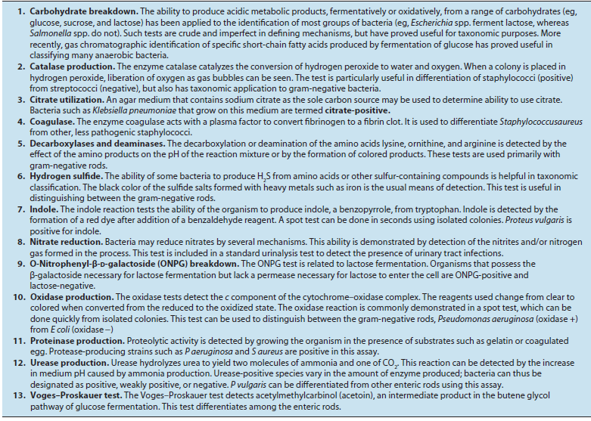

THE GROWTH CURVE IN BATCH CULTURE

If a fixed volume of liquid medium is inoculated with microbial cells taken from a culture that has previously been grown to saturation and the number of viable cells per milliliter is determined periodically and plotted, a curve of the type shown usually obtained. The phases of the bacterial growth curve shown are reflections of the events in a population of cells, not in individual cells. This type of culture is referred to as a batch culture. The typical growth curve may be discussed in terms of four phases. Batch culture is a closed system with finite resources; this is very different from the environment of the human host where nutrients are metabolized by bacteria and human cells. Nonetheless, understanding growth in batch culture provides fundamental insight into the genetics and physiology of bacterial replication, including the lag, exponential, stationary, and death phases that comprise this process.

Idealized bacterial growth curve plotting the log viable cell concentration versus time. Noted in the figure are the lag, log, stationary, and death phases with the approximate rates of increase or decrease representing what one would see upon inoculating a single bacterial colony in a closed batch culture system.
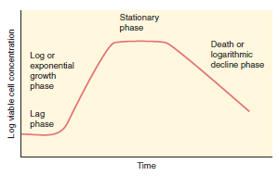

Phases of the Microbial Growth Curve
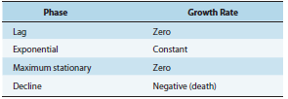

• An organism requires all of the elements in its organic matter and the full complement of ions required for energetics in order to grow. Nutrients are classified according to the elements they provide, including carbon source, nitrogen source, sulfur source, phosphorous source, and mineral sources.
• Growth factors are organic compounds that a cell must have to grow but that it is unable to synthesize.
• There must be a source of energy present to establish a proton motive force and to allow macromolecular synthesis. The three major mechanisms for generating metabolic energy are fermentation, respiration, and photosynthesis.
• Environmental factors such as pH, temperature, and aeration are important for growth. Most human pathogens are neutralophiles (grow best at pH of 6.0–8.0) and mesophilic (grow best at 30–37°C).
• Organisms vary widely in their ability to use oxygen as a hydrogen acceptor and in their ability to inactivate toxic by-products of aerobic metabolism. They may be grouped as obligate aerobes, facultative anaerobes, obligate anaerobes, microaerophiles, and aerotolerant anaerobes.
• Microbiologic media can be formulated to permit the growth of a particular type of microorganism present in low numbers (enrichment culture), identify specific types of microorganisms (differential medium), or isolate a specific organism from a mixed population (selective medium).

ROLE OF METABOLISM IN BIOSYNTHESIS AND GROWTH

Microbial growth requires the polymerization of biochemical building blocks into proteins, nucleic acids, polysaccharides, and lipids. The building blocks must come preformed in the growth medium or must be synthesized by the growing cells. Additional biosynthetic demands are placed by the requirement for coenzymes that participate in enzymatic catalysis.
Biosynthetic polymerization reactions demand the transfer of anhydride bonds from adenosine triphosphate (ATP). Growth demands a source of metabolic energy for the synthesis of anhydride bonds and for the maintenance of transmembrane gradients of ions and metabolites.
Metabolism has two components, catabolism and anabolism.
Catabolism encompasses processes that harvest energy released from the breakdown of compounds (eg, glucose), and using that energy to synthesize ATP. In contrast, anabolism, or biosynthesis, includes processes that utilize the energy stored in ATP to synthesize and assemble the subunits, or building blocks, of macromolecules that make up the cell. The sequence of building blocks within a macromolecule is determined in one of two ways. In nucleic acids and proteins, it is template-directed: DNA serves as the template for its own synthesis and for the synthesis of the various types of RNA; messenger RNA serves as the template for the synthesis of proteins. In carbohydrates and lipids, on the other hand, the arrangement of building blocks is determined entirely by enzyme specificities. Once the macromolecules have been synthesized, they self-assemble to form the supramolecular structures of the cell, eg, ribosomes, membranes, cell wall, flagella, and pili.
The rate of macromolecular synthesis and the activity of metabolic pathways must be regulated so that biosynthesis is balanced. All of the components required for macromolecular synthesis must be present for orderly growth, and control must be exerted so that the resources of the cell are not expended on products that do not contribute to growth or survival. This chapter contains a review of microbial metabolism and its regulation. Microorganisms represent extremes of evolutionary divergence, and a vast array of metabolic pathways
is found within the group. For example, any of more than half a dozen different metabolic pathways may be used for assimilation of a relatively simple compound, benzoate, and a single pathway for benzoate assimilation may be regulated by any of more than half a dozen control mechanisms. Our goal is to illustrate the principles that underlie metabolic pathways and their regulation. The primary principle that determines metabolic pathways is that they are achieved by organizing relatively few biochemical-type reactions in a specific order.
Many biosynthetic pathways can be deduced by examining the chemical structures of the starting material, the end product, and perhaps one or two metabolic intermediates.
The primary principle underlying metabolic regulation is that enzymes tend to be called into play only when their catalytic activity is required. The activity of an enzyme may be changed by varying either the amount of enzyme or the amount of substrate. In some cases, the activity of enzymes may be altered by the binding of specific effectors, metabolites that modulate enzyme activity.

FOCAL METABOLITES AND THEIR INTERCONVERSION

Glucose 6-Phosphate and Carbohydrate Interconversions
The biosynthetic origins of building blocks and coenzymes can be traced to relatively few precursors, called focal metabolites. İllustrate how the respective focal metabolites glucose 6-phosphate (G6PD), phosphoenolpyruvate, oxaloacetate, and α-ketoglutarate give rise to most biosynthetic end products. G6PD is converted to a range of biosynthetic end products via phosphate esters of carbohydrates with different chain lengths.
Carbohydrates possess the empirical formula (CH2O)n, and the primary objective of carbohydrate metabolism is to change n, the length of the carbon chain. Mechanisms by which the chain lengths of carbohydrate phosphates are interconverted are summarized. In one case, oxidative reactions are used to remove a single carbon from G6PD, producing the pentose derivative ribulose 5-phosphate. Isomerase and epimerase reactions interconvert the most common biochemical forms of the pentoses: ribulose 5 phosphate, ribose 5-phosphate, and xylulose 5-phosphate. Transketolases transfer a twocarbon fragment from a donor to an acceptor molecule.
These reactions allow pentoses to form or to be formed from carbohydrates of varying chain lengths. As shown, two pentose 5-phosphates (n = 5) are interconvertible with triose 3-phosphate (n = 3) and heptose 7-phosphate (n = 7); pentose 5-phosphate (n = 5) and tetrose 4-phosphate (n = 4) are interconvertible with triose 3-phosphate (n = 3) and hexose 6-phosphate (n = 6).
The six-carbon hexose chain of fructose 6-phosphate can be converted to two three-carbon triose derivatives by the consecutive action of a kinase and an aldolase on fructose 6 phosphate. Alternatively, aldolases, acting in conjunction with phosphatases, can be used to lengthen carbohydrate molecules: Triose phosphates give rise to fructose 6-phosphate; a triose phosphate and tetrose 4-phosphate form heptose.

Cell structures - (cell wall, membrane, ribosomes, surface structures)
Macromolecules - (proteins, nucleic acids)
Subunits - (amino acids, nucleotides)
Energy source - (glucose)

CATABOLISM ANABOLISM

Nutrients - (source of nitrogen, sulfur, etc)
Waste products - (acids, carbon dioxide)

Precursors
The relationship between catabolism and anabolism. Catabolism encompasses processes that harvest energy released during disassembly of compounds, using it to synthesize adenosine triphosphate (ATP); it also provides precursor metabolites used in biosynthesis. Anabolism, or biosynthesis, includes processes that utilize ATP and precursor metabolites to synthesize and assemble subunits of macromolecules that make up the cell. (Reproduced with permission from Nester EW, Anderson DG, Roberts CE, Nester MT [editors]: Microbiology: A Human Perspective, 6th ed. McGraw-Hill, 2009, p. 127. © The McGraw-Hill Companies, Inc.) 7-phosphate. The final form of carbohydrate chain length interconversion is the transaldolase reaction, which interconverts heptose 7-phosphate and triose 3-phosphate with tetrose 4-phosphate and hexose 6-phosphate.
The coordination of different carbohydrate rearrangement reactions to achieve an overall metabolic goal is illustrated by the hexose monophosphate shunt. This metabolic cycle is used by Cyanobacteria for the reduction of NAD+ (nicotinamide adenine dinucleotide) to NADH (reduced nicotinamide adenine dinucleotide), which serves as a reductant for respiration in the dark. Many organisms use the hexose monophosphate shunt to reduce NADP+ (nicotinamide adenine dinucleotide phosphate) to NADPH (reduced nicotinamide adenine dinucleotide phosphate), which is used for biosynthetic reduction reactions. The first steps in the hexose monophosphate shunt are the oxidative reactions that shorten six hexose 6-phosphates (abbreviated as six C6) to six pentose 5-phosphates (abbreviated six C5). Carbohydrate rearrangement reactions convert the six C5 molecules to five C6 molecules so that the oxidative cycle may continue.
Clearly, all reactions for interconversion of carbohydrate chain lengths are not called into play at the same time. Selection of specific sets of enzymes, essentially the determination of the metabolic pathway taken, is dictated by the source of carbon and the biosynthetic demands of the cell. For example, a cell given triose phosphate as a source of carbohydrate will use the aldolase–phosphatase combination to form fructose 6-phosphate; the kinase that acts on fructose 6-phosphate in its conversion to triose phosphate would not be expected to be active under these circumstances. If demands for pentose 5-phosphate are high, as in the case of photosynthetic carbon dioxide assimilation, transketolases that can give rise to pentose 5-phosphates are very active.
In sum, G6PD can be regarded as a focal metabolite because it serves both as a direct precursor for metabolic building blocks and as a source of carbohydrates of varying length that are used for biosynthetic purposes. G6PD itself may be generated from other phosphorylated carbohydrates by selection of pathways from a set of reactions for chain length interconversion. The reactions chosen are determined by the genetic potential of the cell, the primary carbon source, and the biosynthetic demands of the organism. Metabolic regulation is required to ensure that reactions that meet the requirements of the organism are selected.

The relationship between catabolism and anabolism. Catabolism encompasses processes that harvest energy released during disassembly of compounds, using it to synthesize adenosine triphosphate (ATP); it also provides precursor metabolites used in biosynthesis. Anabolism, or biosynthesis, includes processes that utilize ATP and precursor metabolites to synthesize and assemble subunits of macromolecules that make up the cell.
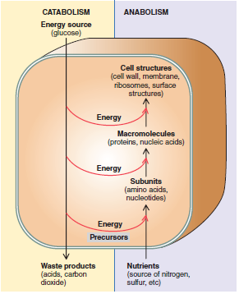

Microbial Fermentations Based on the Embden-Meyerhof Pathway
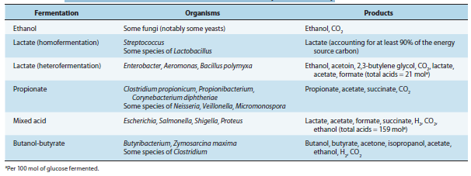

• Metabolism consists of two components, catabolism and anabolism. Catabolism consists of processes that harvest energy from the breakdown of compounds and using that energy to synthesize ATP. Anabolism (or biosynthesis) consists of processes that use the energy stored in ATP to synthesize the subunits (or building blocks) of macromolecules that make up the cell.
• The biosynthetic origins of the building blocks can be traced to relatively few precursors, called focal metabolites.
• Peptidoglycan biosynthesis is unique to bacteria. Some antibiotics kill bacteria by selectively inhibiting steps in peptidoglycan biosynthesis.
• The Embden-Meyerhof, Entner-Doudoroff, and heterolactate pathways are three pathways used for glucose catabolism in bacteria. The pattern of end products is a characteristic used in the identification of bacterial species.
• In the absence of respiration or photosynthesis, bacteria are entirely dependent on substrate phosphorylation for their energy.
• Reductive assimilation of molecular nitrogen (or nitrogen fixation) is required for continuation of life on our planet. It is an energy-intensive process accomplished by a variety of bacteria and Cyanobacteria using a multicomponent nitrogenase enzyme complex.
• The regulation of enzyme activity provides both fine control and coarse control of metabolic pathways so that no intermediate is made in excess.

CULTIVATION AND DETECTION OF VIRUSES
Cultivation of Viruses
Many viruses can be grown in cell cultures or in fertile eggs under strictly controlled conditions. Virus growth in animals is still used for the primary isolation of certain viruses and for studies of the pathogenesis of viral diseases and of viral oncogenesis. Diagnostic laboratories attempt to recover viruses from clinical samples to establish disease causes. Research laboratories cultivate viruses as the basis for detailed analyses of viral replication and protein function.
Cells grown in vitro are central to the cultivation and characterization of viruses. There are three basic types of cell cultures. Primary cultures are made by dispersing cells (usually with trypsin) from freshly removed host tissues. In general, they are unable to grow for more than a few passages in culture. Diploid cell lines are secondary cultures that have undergone a change that allows their limited culture (up to 50 passages) but that retain their normal chromosome pattern. Continuous cell lines are cultures capable of more prolonged—perhaps indefinite— growth that have been derived from diploid cell lines or from malignant tissues. These have altered and irregular numbers of chromosomes. The type of cell culture used for viral cultivation depends on the sensitivity of the cells to a particular virus.

A. Detection of Virus-Infected Cells
Multiplication of a virus can be monitored in a variety of ways:
1. Development of cytopathic effects (ie, morphologic changes in the cells). Types of virus-induced cytopathic effects include cell lysis or necrosis, inclusion body formation, giant cell formation, and cytoplasmic vacuolization.
2. Appearance of a virus-encoded protein, such as the hemagglutinin of influenza virus. Specific antisera can be used to detect the synthesis of viral proteins in infected cells.
3. Detection of virus-specific nucleic acid. Molecular-based assays such as polymerase chain reaction provide rapid, sensitive, and specific methods of detection.
4. Adsorption of erythrocytes to infected cells, called hemadsorption, caused by the presence of virus-encoded hemagglutinin (parainfluenza, influenza) in cellular membranes. This reaction becomes positive before cytopathic changes are visible and in some cases occurs in the absence of cytopathic effects.
5. Viral growth in an embryonated chick egg may result in death of the embryo (eg, encephalitis viruses), production of pocks or plaques on the chorioallantoic membrane (eg, herpes, smallpox, vaccinia), or development of hemagglutinins in the embryonic fluids or tissues (eg, influenza).

B. Inclusion Body Formation
In the course of viral multiplication within cells, virus specific structures called inclusion bodies may be produced. They become far larger than the individual virus particle and often have an affinity for acid dyes (eg, eosin). They may be situated in the nucleus, in the cytoplasm (poxvirus, rabies virus), or in both. In many viral infections, the inclusion bodies are the site of development of the virions (the viral factories). Variations in the appearance of inclusion material depend on the tissue fixative and stain used.

Quantitation of Viruses
A. Physical Methods
Quantitative nucleic acid-based assays such as the polymerase chain reaction can determine the number of viral genome copies in a sample. Both infectious and noninfectious genomes are detected. Virus sequence variation may reduce virus detection and quantitation by this method. A variety of serologic tests such as radioimmunoassays and enzyme-linked immunosorbent assays can be standardized to quantitate the amount of virus in a sample. These tests do not distinguish infectious from noninfectious particles and sometimes detect viral proteins not assembled into particles. Certain viruses contain a protein (hemagglutinin) that has the ability to agglutinate red blood cells of humans or some animal. Hemagglutination assays are an easy and rapid method of quantitating these types of viruses. Both infective and noninfective particles give this reaction; thus, hemagglutination measures the total quantity of virus present. Virus particles can be counted directly in the electron microscope by comparison with a standard suspension of latex particles of similar small size. However, a relatively concentrated preparation of virus is necessary for this procedure, and infectious virus particles cannot be distinguished from noninfectious ones.

B. Biologic Methods
End point biologic assays depend on the measurement of animal death, animal infection, or cytopathic effects in tissue culture at a series of dilutions of the virus being tested. The titer is expressed as the 50% infectious dose (ID50), which is the reciprocal of the dilution of virus that produces the effect in 50% of the cells or animals inoculated. The ratio of the number of infectious particles to the total number of virus particles varies widely, from near unity to less than one per 1000, but often is one per several hundred. Precise assays require the use of a large number of replicates.
A widely used assay for infectious virus is the plaque assay, although it can only be used for viruses that grow well in tissue culture. Monolayers of host cells are inoculated with suitable dilutions of virus and after adsorption are overlaid with medium containing agar or carboxymethylcellulose to prevent virus spreading throughout the culture. After several days, the cells initially infected have produced virus that spreads only to surrounding cells. Multiple cycles of replication and cell killing produce a small area of infection, or plaque. The length of time from infection to when plaques can be visualized for counting depends on the replication cycle of the virus and can range from a few days (eg, poliovirus) to 2 weeks or more (eg, SV40). Under controlled conditions, a single plaque can arise from a single clonal infectious virus particle, termed a plaque-forming unit. The cytopathic effect of infected cells within the plaque can be distinguished from uninfected cells of the monolayer with or without suitable staining, and plaques can usually be counted macroscopically. A more rapid method of assay is based on determination of the number of infected cells producing a viral antigen, such as by immunofluorescence. Certain viruses (eg, herpes and vaccinia) form pocks when inoculated onto the chorioallantoic membrane of an embryonated egg. Such viruses can be quantitated by relating the number of pocks counted to the viral dilution inoculated.

PURIFICATION AND IDENTIFICATION OF VIRUSES

Purification of Virus Particles
Pure virus must be available in order for certain types of studies on the properties and molecular biology of the agent to be carried out. For purification studies, the starting material is usually large volumes of tissue culture medium, body fluids, or infected cells. The first step frequently involves concentration of the virus particles by precipitation with ammonium sulfate, ethanol, or polyethylene glycol or by ultrafiltration. Hemagglutination and elution can be used to concentrate orthomyxoviruses. After concentration, virus can be separated from host materials by differential centrifugation, density gradient centrifugation, column chromatography, and electrophoresis. More than one step is usually necessary to achieve adequate purification. A preliminary purification will remove most nonviral material. This first step may include centrifugation; the final purification step almost always involves density gradient centrifugation. In rate-zonal centrifugation, a sample of concentrated virus is layered onto a preformed linear density gradient of sucrose or glycerol, and during centrifugation the virus sediments as a band at a rate determined primarily by the density of the virus particle. Viruses can also be purified by high-speed centrifugation in density gradients of cesium chloride, potassium tartrate, potassium citrate, or sucrose. The gradient material of choice is the one that is least toxic to the virus. Virus particles migrate to an equilibrium position where the density of the solution is equal to their buoyant density and form a visible band. Additional methods for purification are based on the chemical properties of the viral surface. In column chromatography, virus is bound to a substance such as diethylaminoethyl or phosphocellulose and then eluted by changes in pH or salt concentration. Zone electrophoresis permits separation of virus particles from contaminants on the basis of charge. Specific antisera also can be used to remove virus particles from host materials. Icosahedral viruses are easier to purify than enveloped viruses. Because the latter usually contain variable amounts of envelope per particle, the viral population is heterogeneous in both size and density. It is very difficult to achieve complete purity of viruses. Small amounts of cellular material tend to adsorb to particles and copurify. The minimal criteria for purity are a homogeneous appearance in electron micrographs and the failure of additional purification procedures to remove “contaminants” without reducing infectivity.

Identification of a Particle as a Virus
When a characteristic physical particle has been obtained, it should fulfill the following criteria before it is identified as a virus particle:
1. The particle can be obtained only from infected cells or tissues.
2. Particles obtained from various sources are identical regardless of the cellular origin in which the virus is grown.
3. Particles contain nucleic acid (DNA or RNA), the sequence of which is not the same as the species of host cells from which the particles were obtained.
4. The degree of infective activity of the preparation varies directly with the number of particles present.
5. Destruction of the physical particle by chemical or physical means is associated with a loss of viral activity.
6. Certain properties of the particles and infectivity must be shown to be identical (eg, their sedimentation behavior in the ultracentrifuge and their pH stability curves).
7. Antisera prepared against the infectious virus should react with the characteristic particle and vice versa. Direct observation of an unknown virus can be accomplished by electron microscopic examination of aggregate formation in a mixture of antisera and crude viral suspension.
8. The particles should be able to induce the characteristic disease in vivo (if such experiments are feasible).
9. Passage of the particles in tissue culture should result in the production of progeny with biologic and antigenic properties of the virus.

Pathways of Nucleic Acid Transcription for Various Virus Classes
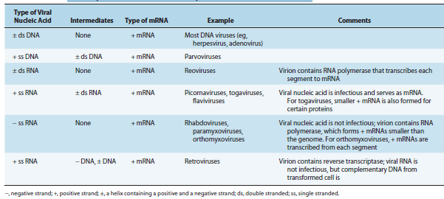

Comparison of Replication Strategies of Several Important RNA Virus Families
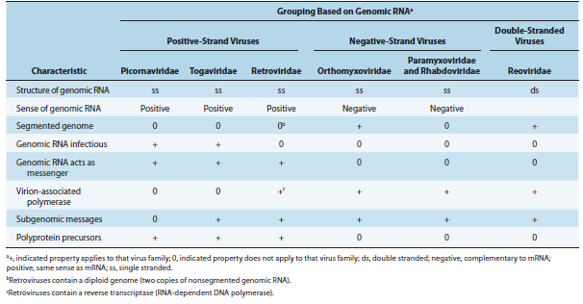

Summary of Replication Cycles of Major Virus Families
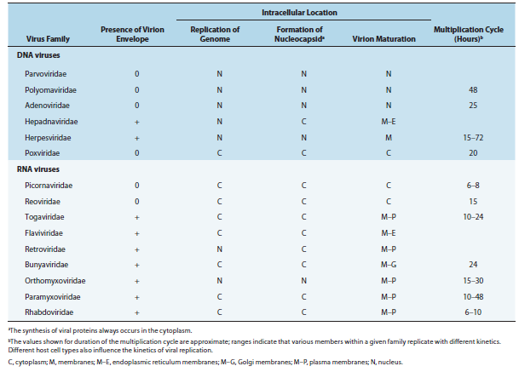

• Viruses are the smallest infectious agents and contain only one type of nucleic acid (DNA or RNA).
• Known viruses are highly diverse, varying in size, shape, and genetic content; some types possess a lipid envelope.
• Viruses are classified into groups, designated virus families, based on common properties, such as virion morphology, genome structure, virus protein properties, and strategies of replication.
• Viruses are obligate intracellular parasites and multiply only in living cells. The viral nucleic acid encodes virusspecific products, and the host cell provides energy, biochemical precursors, and biosynthetic machinery.
• Steps in viral replication include attachment to a cell via binding to specific receptors on the cell surface, entry into the cell, uncoating of the viral genome, regulated expression of viral transcripts, synthesis of viral proteins, replication of viral genomic nucleic acid, assembly of new progeny viruses, and release of new virions from the cell. The duration of replication cycles varies widely among different virus types. The infected cells may be killed or may survive with little damage. Not all infections lead to new progeny virus.
• New viral diseases are emerging, termed “emerging infectious diseases,” as new agents are recognized, known agents evolve and spread, and new host populations become infected.
• Some viruses are potential bioterrorism agents based on ease of host-to-host transmission and mortality rates.

